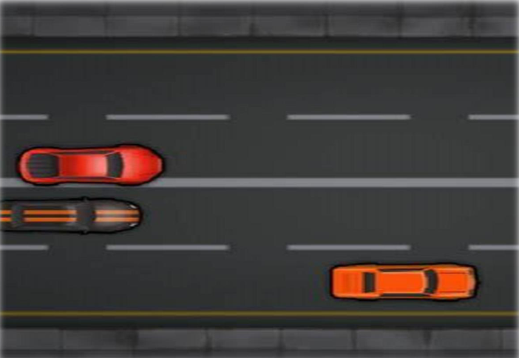
بسم الله الرحمن الرحیم

پروژه ماشین بازی

درس برنامه سازی پیشرفته

امیرحسین حنیفی

مقدمه
در این پروژه قصد داریمبه سبک کنسول های قدیمی،بازیCar game
را پیاده سازی کنیم.

شرح پروژه

در این بازی با استفاده ازمفاهیم شی گرایی و کالسبه صورت متداولماشین هایی با
موقعیت هایمتفاوت (رندم) وارد صفحه میشوند کهسرعت انها نیز متفاوت است وشما
باید بدون اصابت کردن،آن ها را رد کنید.
توجه کنید که بایدترفند هایی پیاده کنید کهامکانبسته شدن راه توسط ماشین های
دیگر وجود نداشته باشد.

#ifndef CARGAME_HPP
#define CARGAME_HPP

#include <iostream>
#include <windows.h>

#define SCREEN_WIDTH 90
#define SCREEN_HEIGHT 26
#define WIN_WIDTH 70
class CarGame {
private:
HANDLE console;
COORD CursorPosition;

int enemyY[3];
int enemyX[3];
int enemyFlag[3];
char car[4][4] = { ' ','*','*',' ',
'*','*','*','*',
' ','*','*',' ',
'*','*','*','*' };

int carPos;
int score;

public:
CarGame();

void gotoxy(int x, int y);

void setcursor(bool visible, DWORD size);

void drawBorder();

void genEnemy(int ind);

void drawEnemy(int ind);

void eraseEnemy(int ind);

void resetEnemy(int ind);

void drawCar();

void eraseCar();

int collision();

void gameover();

void updateScore();

void instructions();

void play();

void menu();
};

#endif // CARGAME_HPP

#include <iostream>
#include <fstream>

int main() {
CarGame carGame;
carGame.menu();

return 0;
}

#include<iostream>
#include<conio.h>
#include<dos.h>
#include <windows.h>
#include <time.h>
#include "carGame.hpp"

using namespace std;

CarGame::CarGame() {
console = GetStdHandle(STD_OUTPUT_HANDLE);
carPos = WIN_WIDTH / 2;
score = 0;
}

void CarGame:: gotoxy(int x, int y) {
CursorPosition.X = x;
CursorPosition.Y = y;
SetConsoleCursorPosition(console, CursorPosition);
}

void CarGame:: setcursor(bool visible, DWORD size) {
if (size == 0)
size = 20;

CONSOLE_CURSOR_INFO lpCursor;
lpCursor.bVisible = visible;
lpCursor.dwSize = size;
SetConsoleCursorInfo(console, &lpCursor);
}

void CarGame::drawBorder() {
for (int i = 0; i < SCREEN_HEIGHT; i++) {
for (int j = 0; j < 17; j++) {
gotoxy(0 + j, i); cout << "*";
gotoxy(WIN_WIDTH - j, i); cout << "*";
}
}
for (int i = 0; i < SCREEN_HEIGHT; i++) {
gotoxy(SCREEN_WIDTH, i); cout << "*";
}
}

void CarGame:: genEnemy(int ind) {
enemyX[ind] = 17 + rand() % (33);
}

void CarGame:: drawEnemy(int ind) {
if (enemyFlag[ind] == true) {
gotoxy(enemyX[ind], enemyY[ind]); cout << "****";
gotoxy(enemyX[ind], enemyY[ind] + 1); cout << " ** ";
gotoxy(enemyX[ind], enemyY[ind] + 2); cout << "****";
gotoxy(enemyX[ind], enemyY[ind] + 3); cout << " ** ";
}
}

void CarGame:: eraseEnemy(int ind) {
if (enemyFlag[ind] == true) {
gotoxy(enemyX[ind], enemyY[ind]); cout << " ";
gotoxy(enemyX[ind], enemyY[ind] + 1); cout << " ";
gotoxy(enemyX[ind], enemyY[ind] + 2); cout << " ";
gotoxy(enemyX[ind], enemyY[ind] + 3); cout << " ";
}
}

void CarGame:: resetEnemy(int ind) {
eraseEnemy(ind);
enemyY[ind] = 1;
genEnemy(ind);
}

void CarGame:: drawCar() {
for (int i = 0; i < 4; i++) {
for (int j = 0; j < 4; j++) {
gotoxy(j + carPos, i + 22); cout << car[i][j];
}
}
}

void CarGame:: eraseCar() {
for (int i = 0; i < 4; i++) {
for (int j = 0; j < 4; j++) {
gotoxy(j + carPos, i + 22); cout << " ";
}
}
}

int CarGame:: collision() {
if (enemyY[0] + 4 >= 23) {
if (enemyX[0] + 4 - carPos >= 0 && enemyX[0] + 4 - carPos < 9) {
return 1;
}
}
return 0;
}

void CarGame:: gameover() {
system("cls");
cout << endl;
cout << "\t\t--------------------------" << endl;
cout << "\t\t-------- Game Over -------" << endl;
cout << "\t\t--------------------------" << endl << endl;
cout << "\t\tPress any key to go back to menu.";
getch();
}

void CarGame:: updateScore() {
gotoxy(WIN_WIDTH + 7, 5); cout << "Score: " << score << endl;
}

void CarGame:: instructions() {
system("cls");
cout << "Instructions";
cout << "\n----------------";
cout << "\n Avoid Cars by moving left or right. ";
cout << "\n\n Press 'a' to move left";
cout << "\n Press 'd' to move right";
cout << "\n Press 'escape' to exit";
cout << "\n\nPress any key to go back to menu";
getch();
}

void CarGame:: play() {
carPos = -1 + WIN_WIDTH / 2;
score = 0;
enemyFlag[0] = 1;
enemyFlag[1] = 0;
enemyY[0] = enemyY[1] = 1;

system("cls");
drawBorder();
updateScore();
genEnemy(0);
genEnemy(1);

gotoxy(WIN_WIDTH + 7, 2); cout << "Car Game";
gotoxy(WIN_WIDTH + 6, 4); cout << "----------";
gotoxy(WIN_WIDTH + 6, 6); cout << "----------";
gotoxy(WIN_WIDTH + 7, 12); cout << "Control ";
gotoxy(WIN_WIDTH + 7, 13); cout << "-------- ";
gotoxy(WIN_WIDTH + 2, 14); cout << " A Key - Left";
gotoxy(WIN_WIDTH + 2, 15); cout << " D Key - Right";

gotoxy(18, 5); cout << "Press any key to start";
getch();
gotoxy(18, 5); cout << " ";

while (1) {
if (kbhit()) {
char ch = getch();
if (ch == 'a' || ch == 'A') {
if (carPos > 18)
carPos -= 4;
}
if (ch == 'd' || ch == 'D') {
if (carPos < 50)
carPos += 4;
}
if (ch == 27) {
break;
}
}

drawCar();
drawEnemy(0);
drawEnemy(1);
if (collision() == 1) {
gameover();
return;
}
Sleep(50);
eraseCar();
eraseEnemy(0);
eraseEnemy(1);

if (enemyY[0] == 10)
if (enemyFlag[1] == 0)
enemyFlag[1] = 1;

if (enemyFlag[0] == 1)
enemyY[0] += 1;

if (enemyFlag[1] == 1)
enemyY[1] += 1;

if (enemyY[0] > SCREEN_HEIGHT - 4) {
resetEnemy(0);
score++;
updateScore();
}
if (enemyY[1] > SCREEN_HEIGHT - 4) {
resetEnemy(1);
score++;
updateScore();
}
}
}

void CarGame:: menu() {
do {
system("cls");
gotoxy(10, 5); cout << " -------------------------- ";
gotoxy(10, 6); cout << " | Car Game | ";
gotoxy(10, 7); cout << " --------------------------";
gotoxy(10, 9); cout << "1. Start Game";
gotoxy(10, 10); cout << "2. Instructions";
gotoxy(10, 11); cout << "3. Quit";
gotoxy(10, 13); cout << "Select option: ";
char op = getche();

if (op == '1') play();
else if (op == '2') instructions();
else if (op == '3') exit(0);

} while (1);
}

خروجی:
